Department of Electrical and Electronics Engineering

Virtual Instrumentation

Lab record

Name : Chirag Hs

Usn : 1MS17EE019

|  |  |
| --- | --- |
| Sl.no | Name of the experiment |
| 1. | Evaluating Mathematical expression |
| 2. | Highest of three numbers |
| 3. | Formula Node |
| 4. | Degree Celsius to farheneit |
| 5. | Compare |
| 6. | Mathematical expression |
| 7. | Random number generator |
| 8. | Change position of button |
| 9. | Generate sound of frequency |
| 10. | 5 sensor temperature checker |
| 11. | Highest of given temperature using Max and min array |
| 12. | Login system |
| 13. | Odd or even system |
| 14. | Simulate sine graph |
| 15. | Equalizer |
| 16. | Ir sensor |
| 17. | Motor speed control |
| 18. | Temperature limit message |
| 19. | Pict ring animation |
| 20. | Accelerometer |
| 21. | One Sensor 5 inputs |
| 22. | Array generate and compare |
| 23. | PDF reader |
| 24. | Motor control using sensor value |
| 25. | Led control using accelerometer |

1)Evaluating mathematical expression

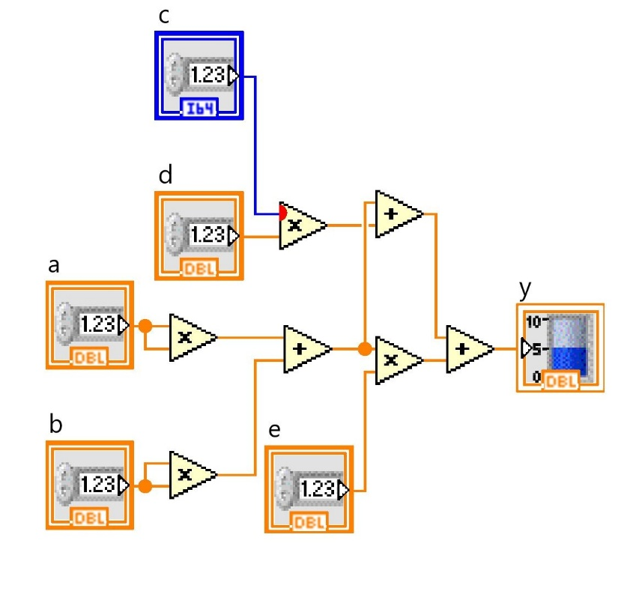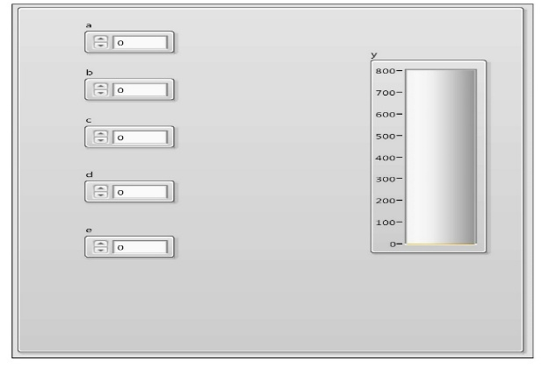

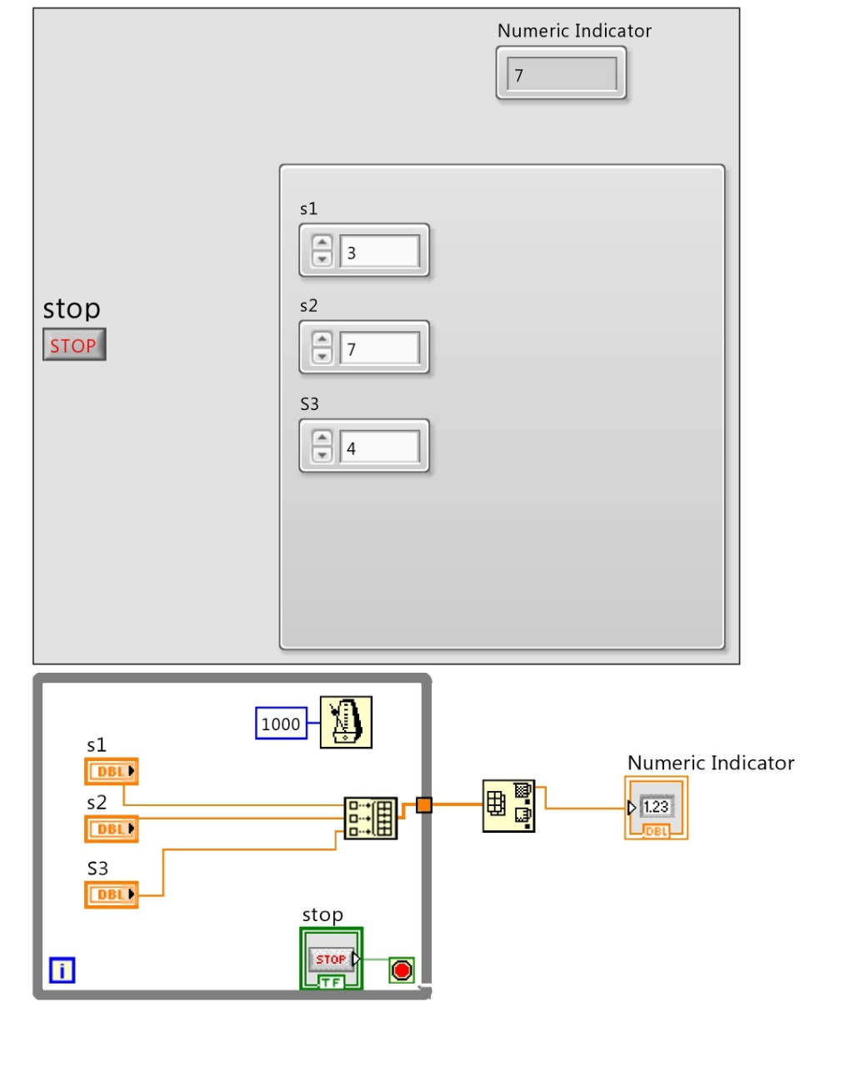2)Highest of 3 numbers

3)Formula Node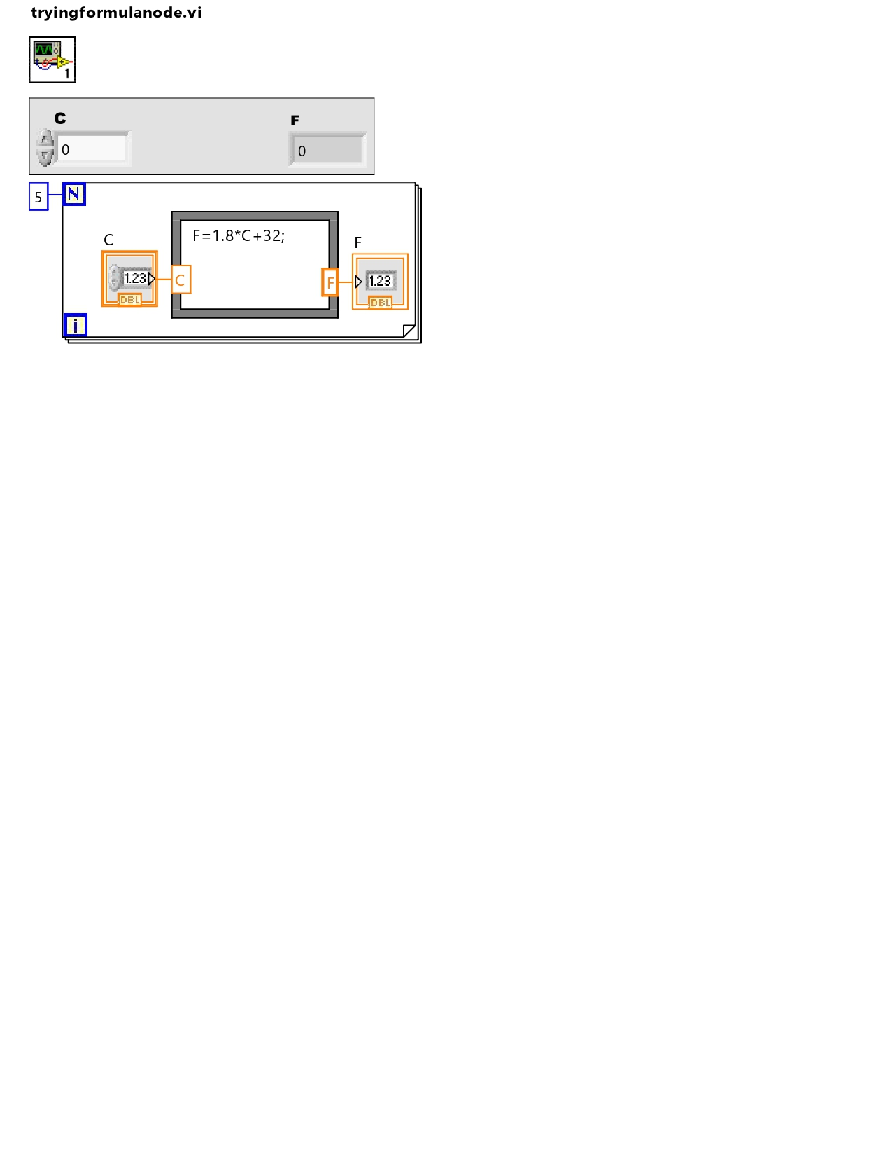

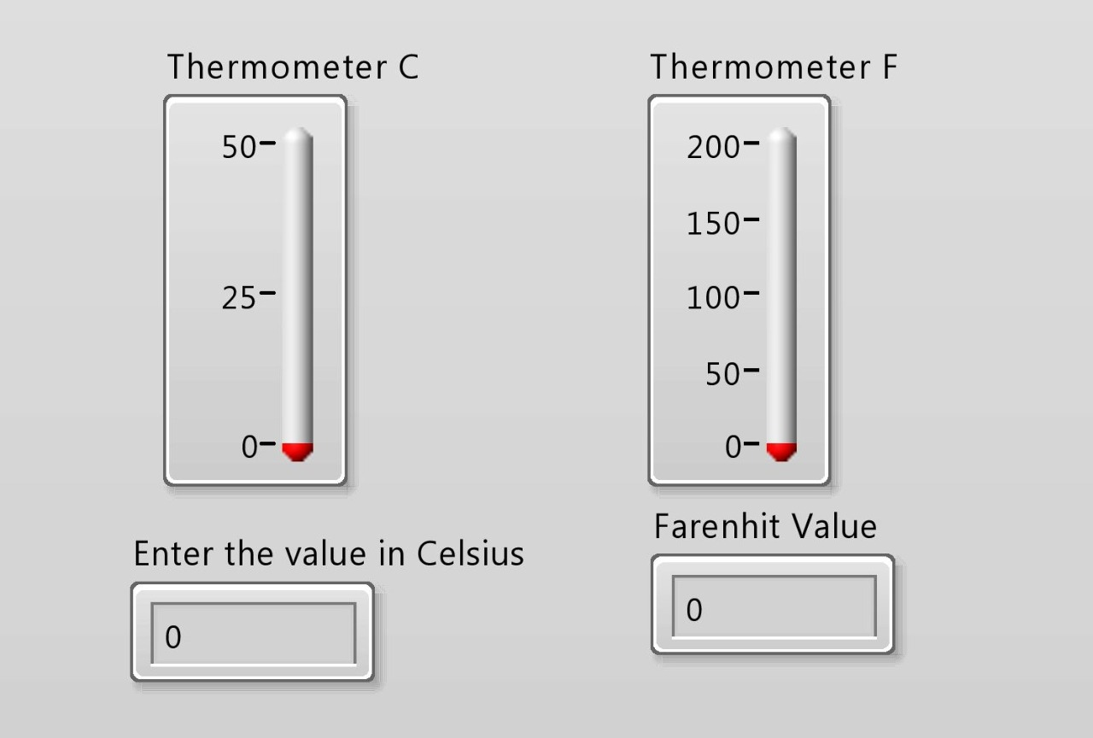4) Degree Celsius to farheneit converter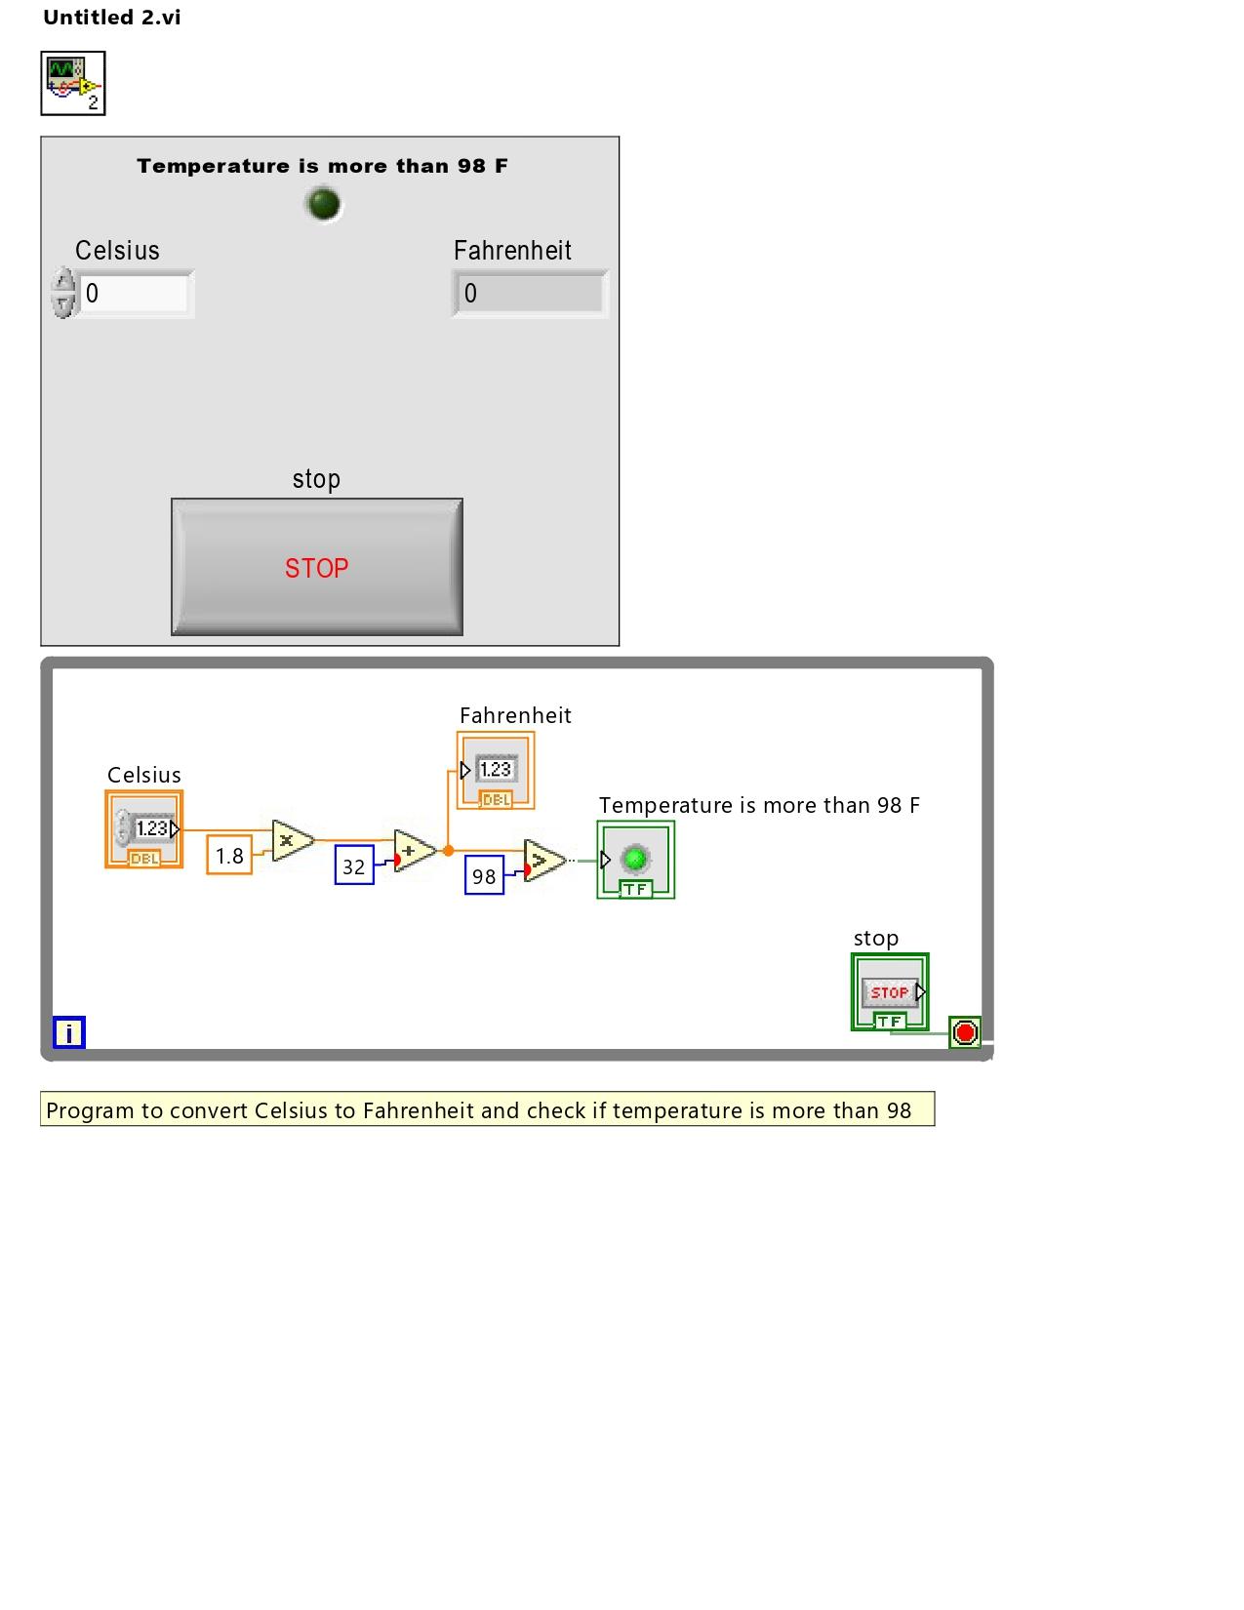

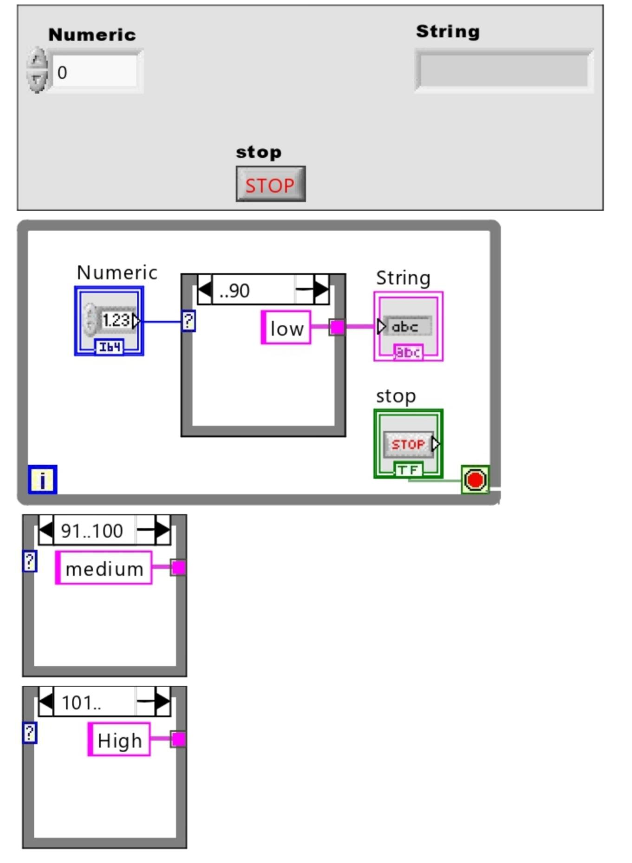5)Compare

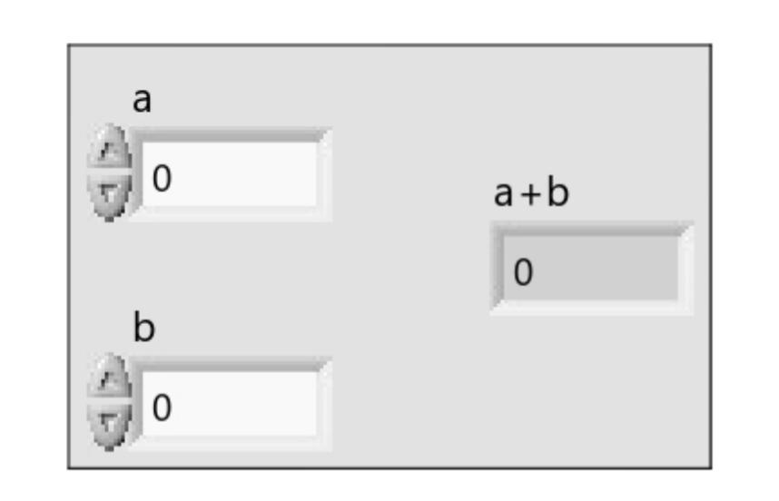6) Mathematical expression

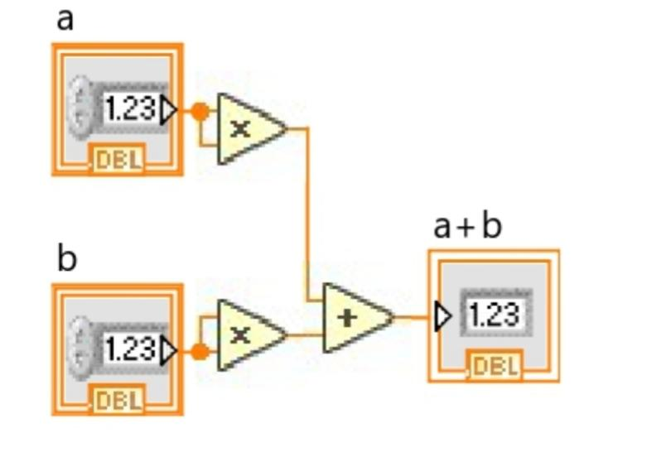

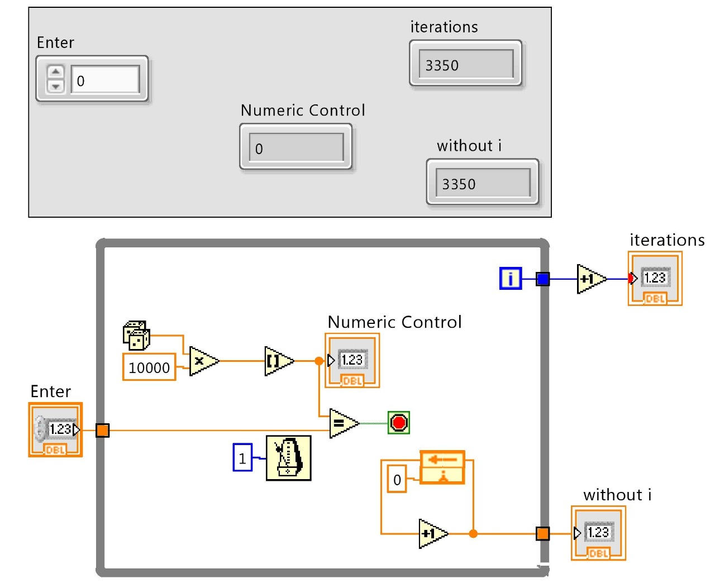7)Random Number Generator

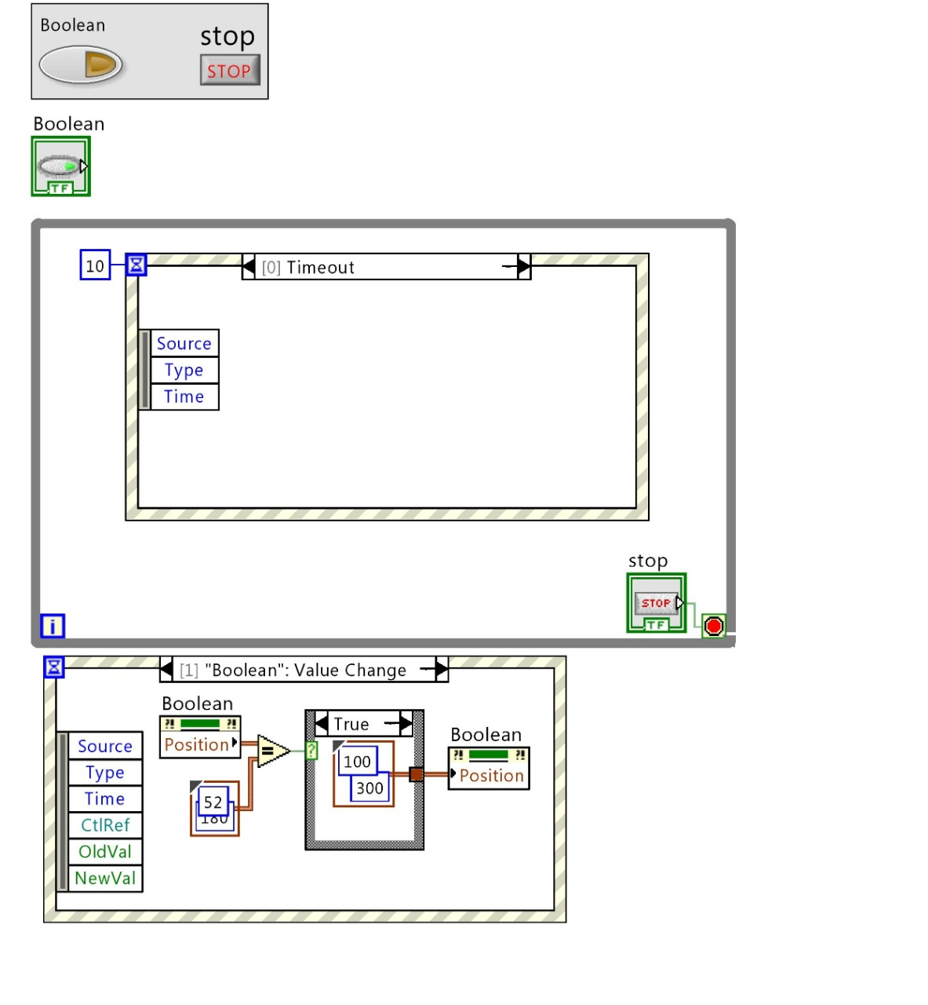8)Position Change of Button

9)Generate Sound of different frequency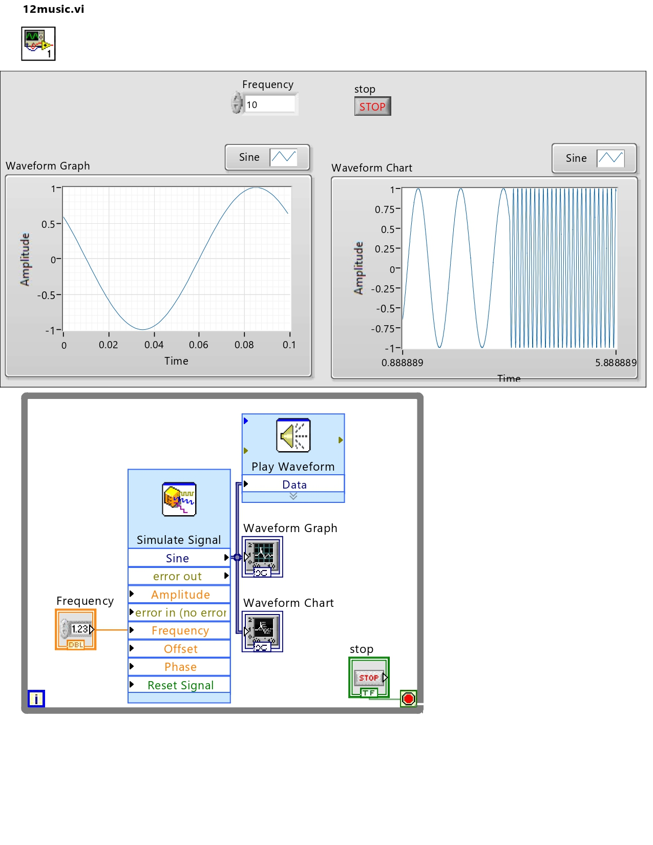

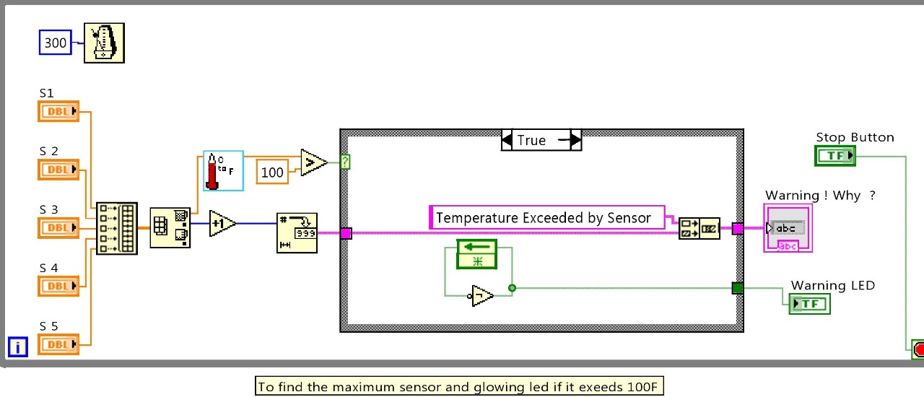10)5 sensor Temperature checker

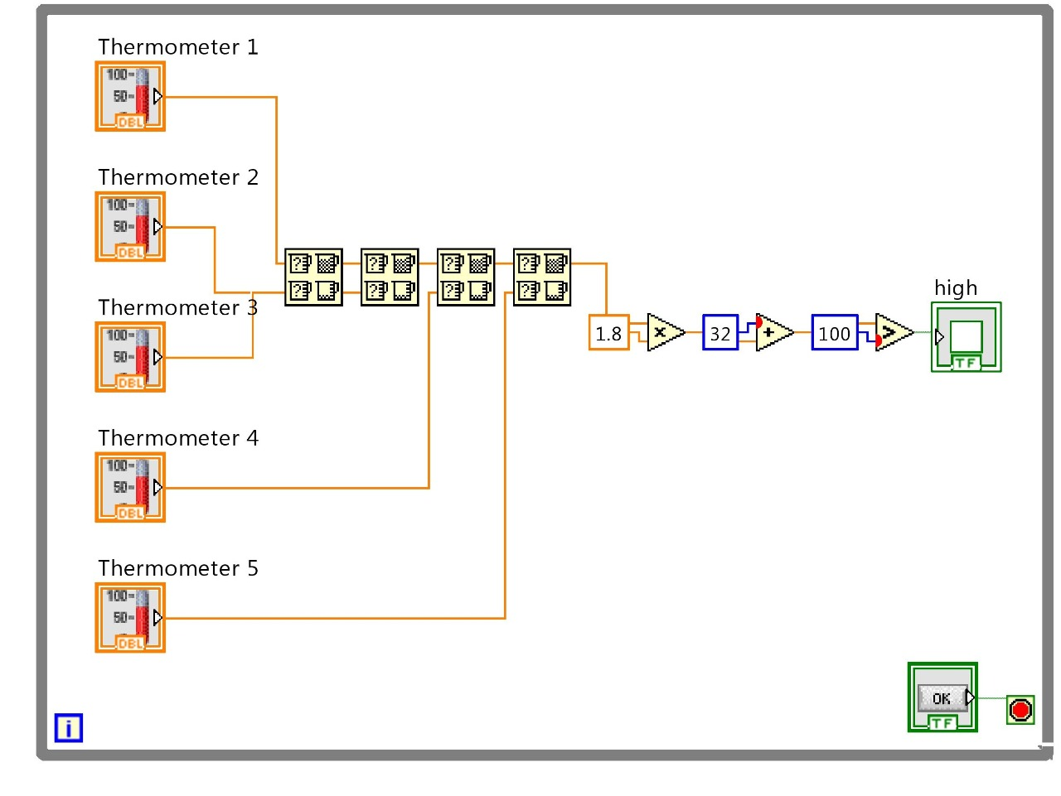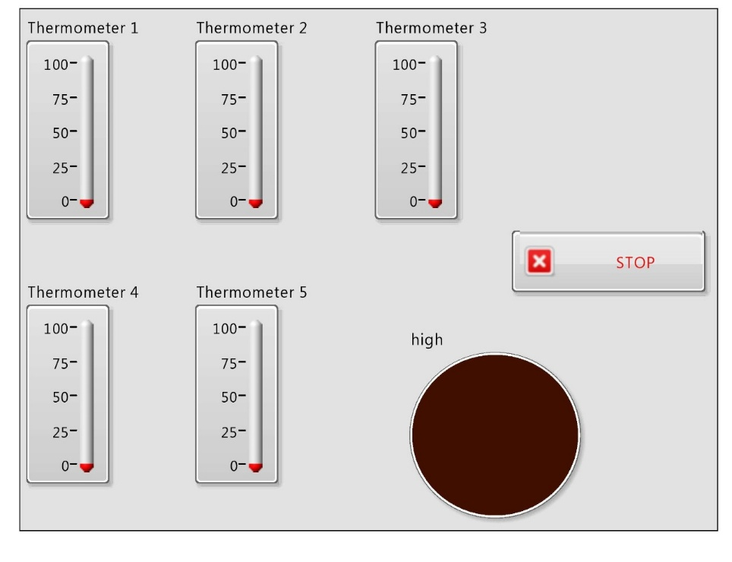11)High temperature check Max and min array

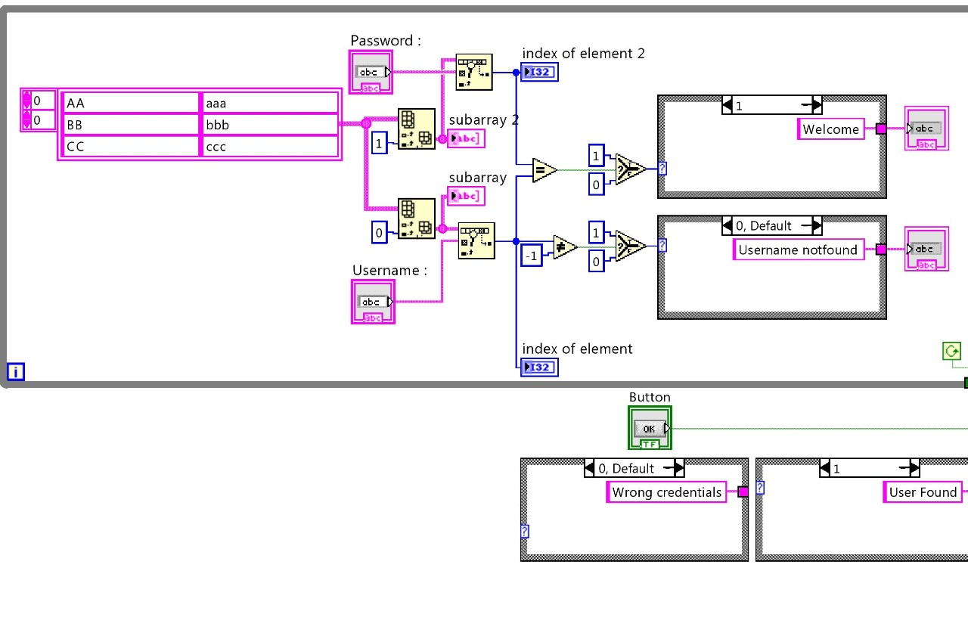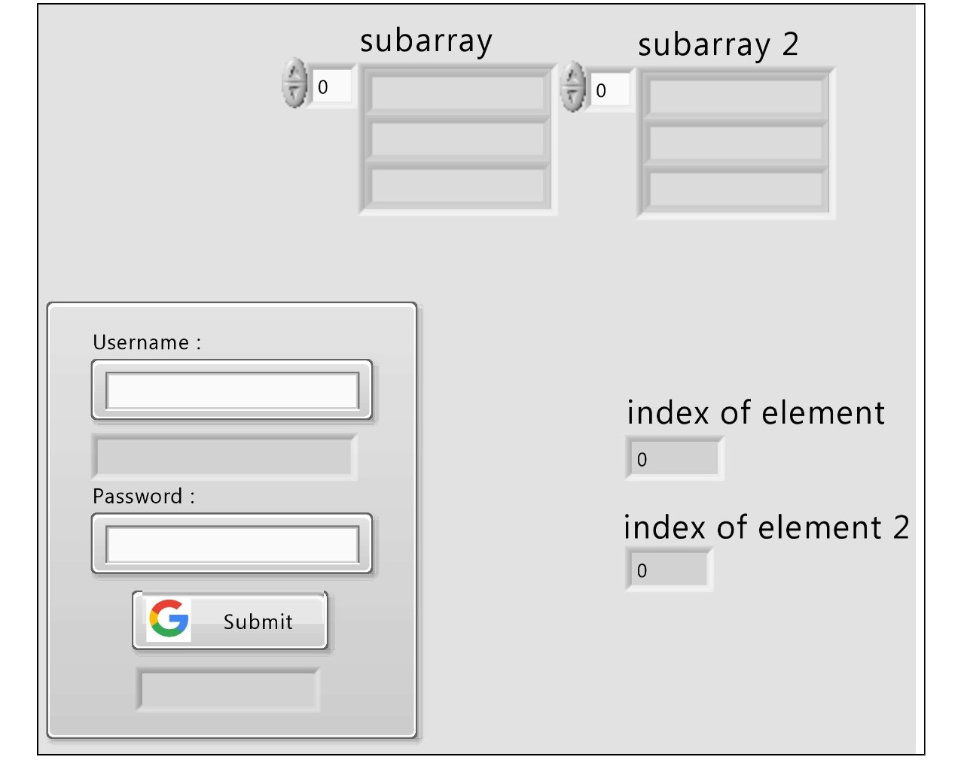12)Login System

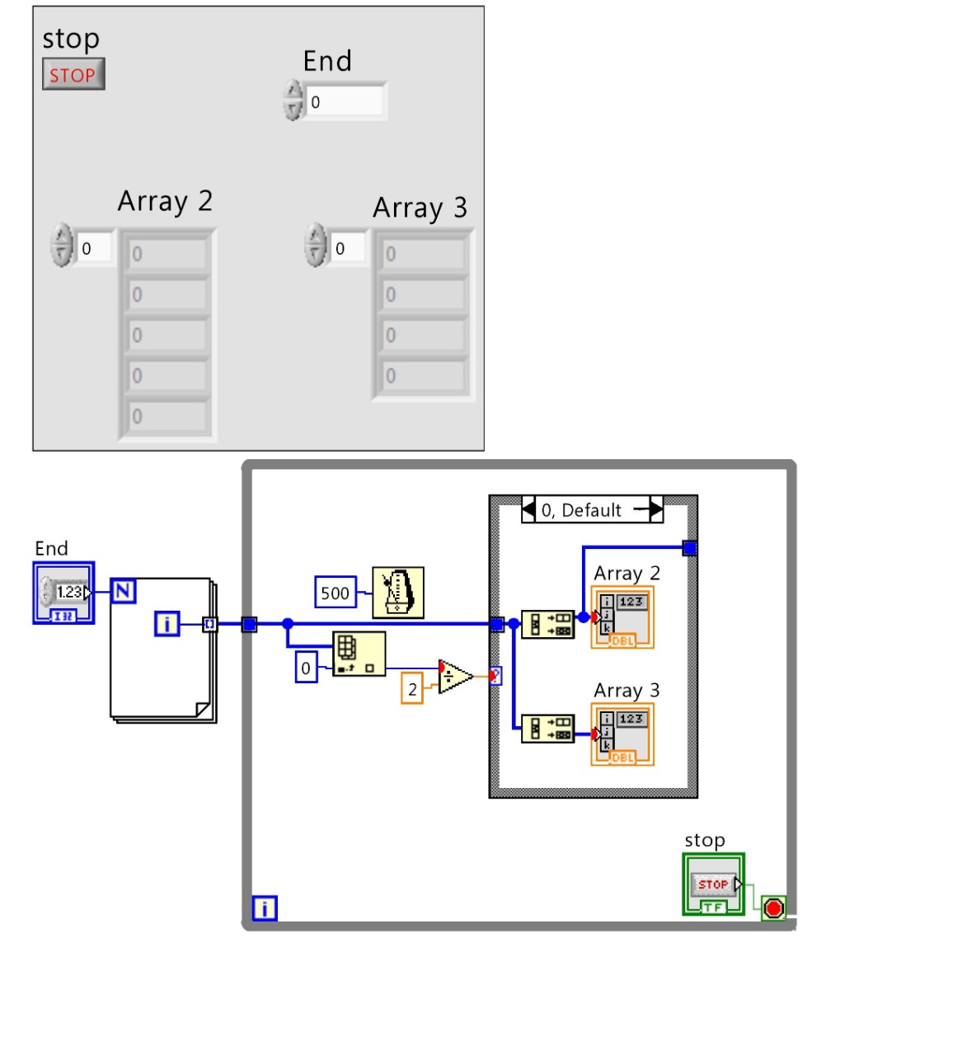13)Odd or even

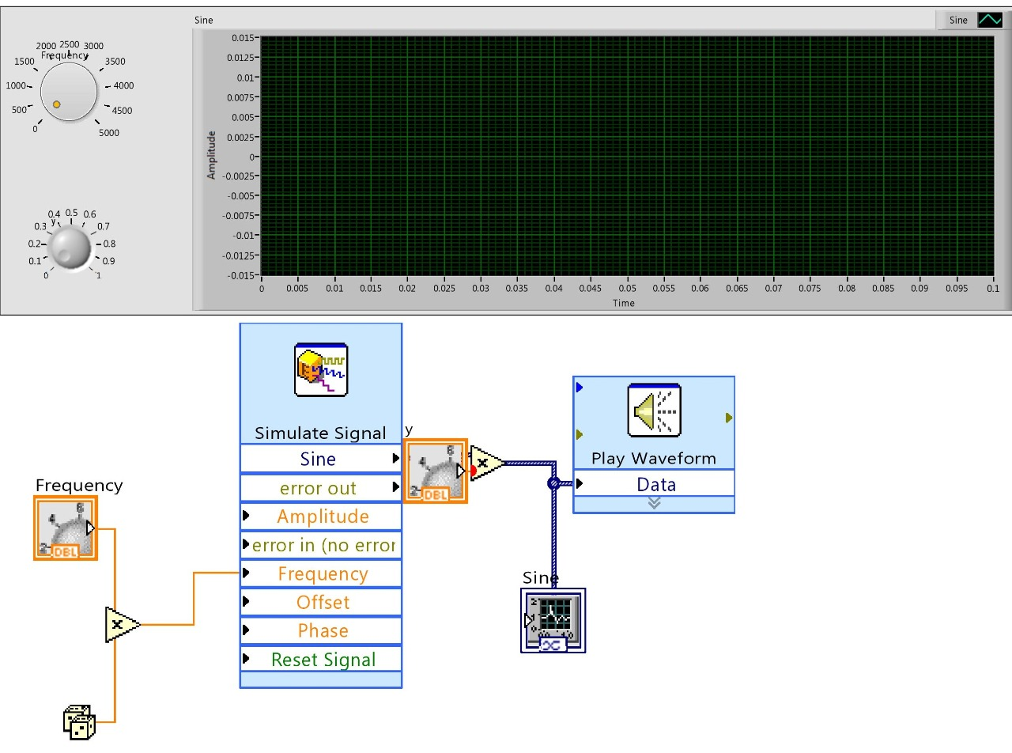14)simulate sine wavegraphs

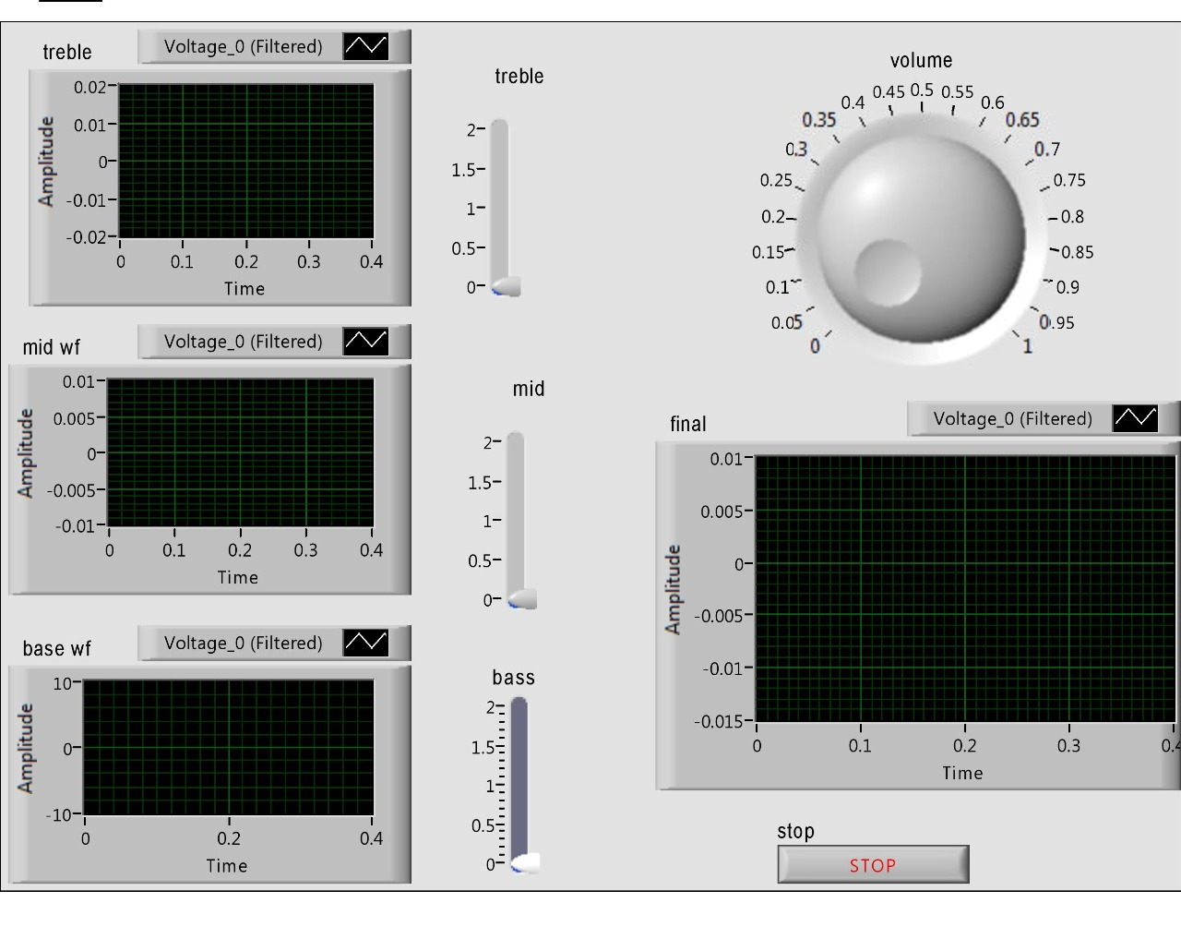15)Equalizer

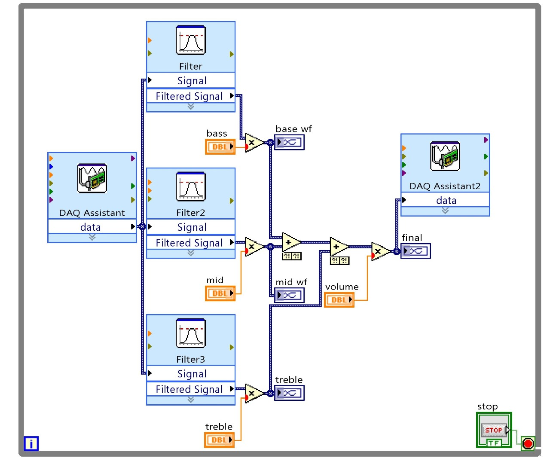

16)Ir sensor

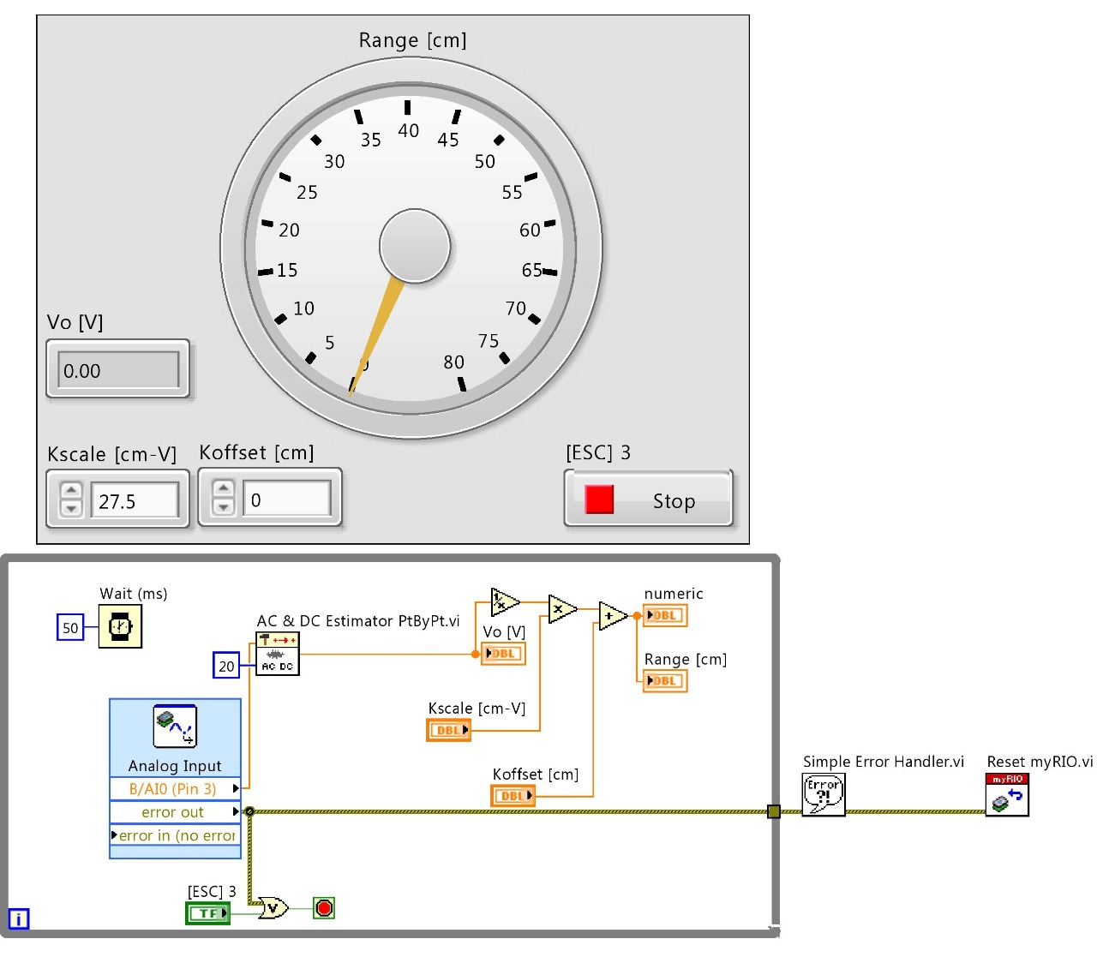

17)Motor speed control

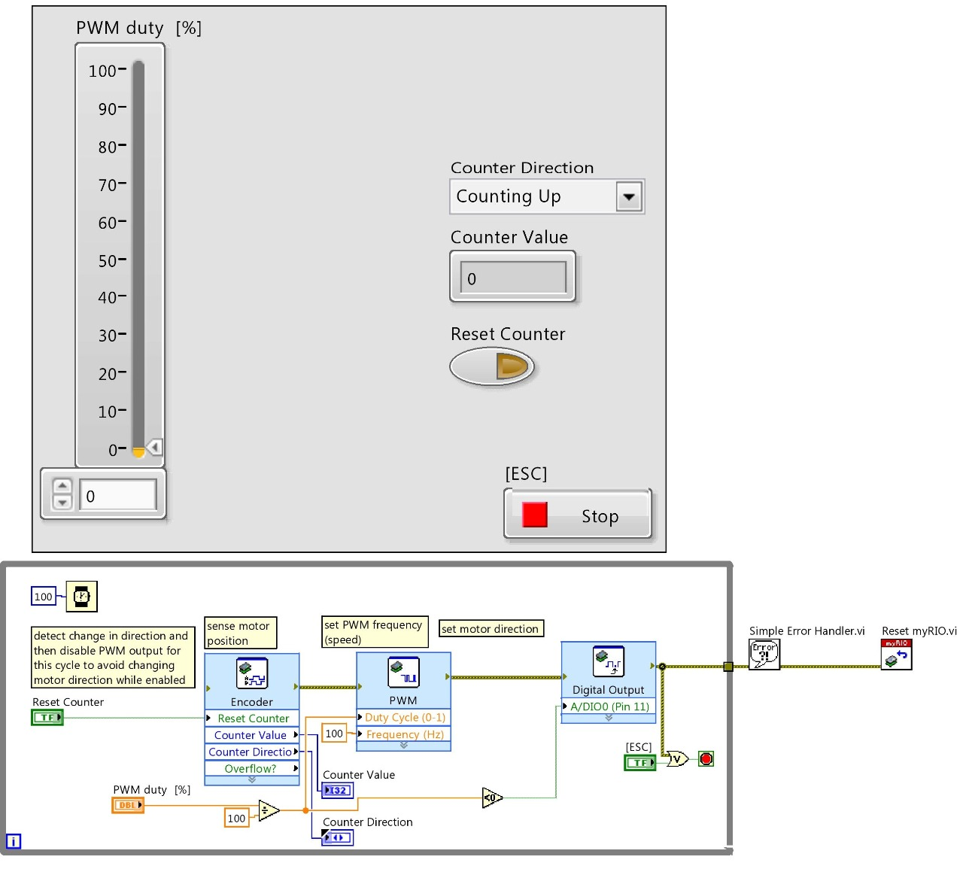

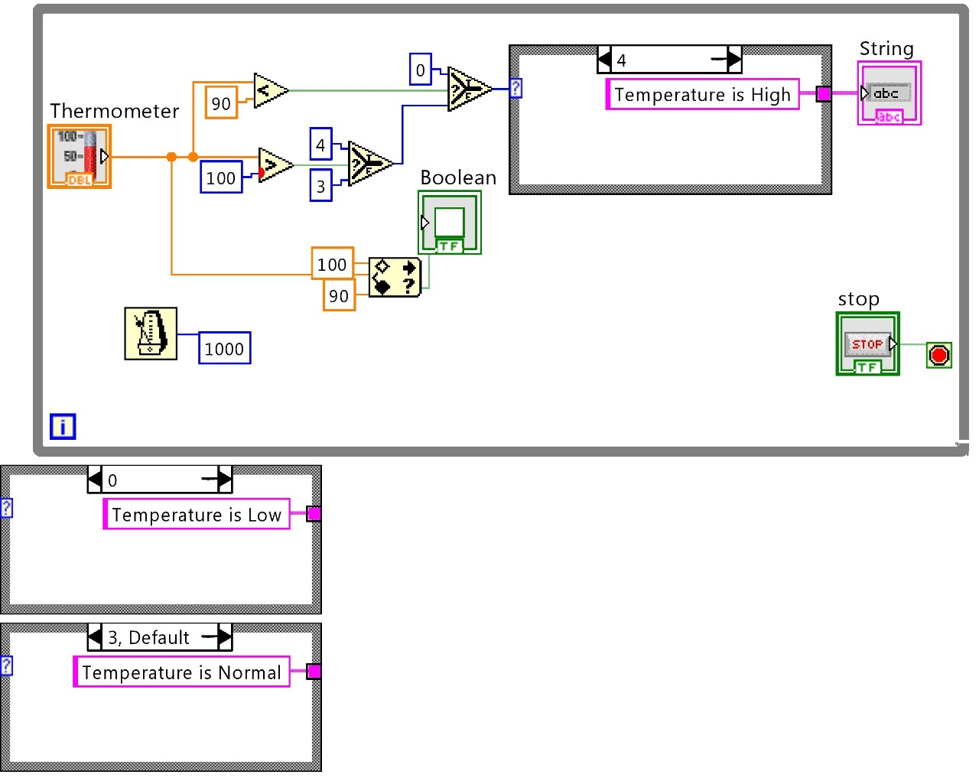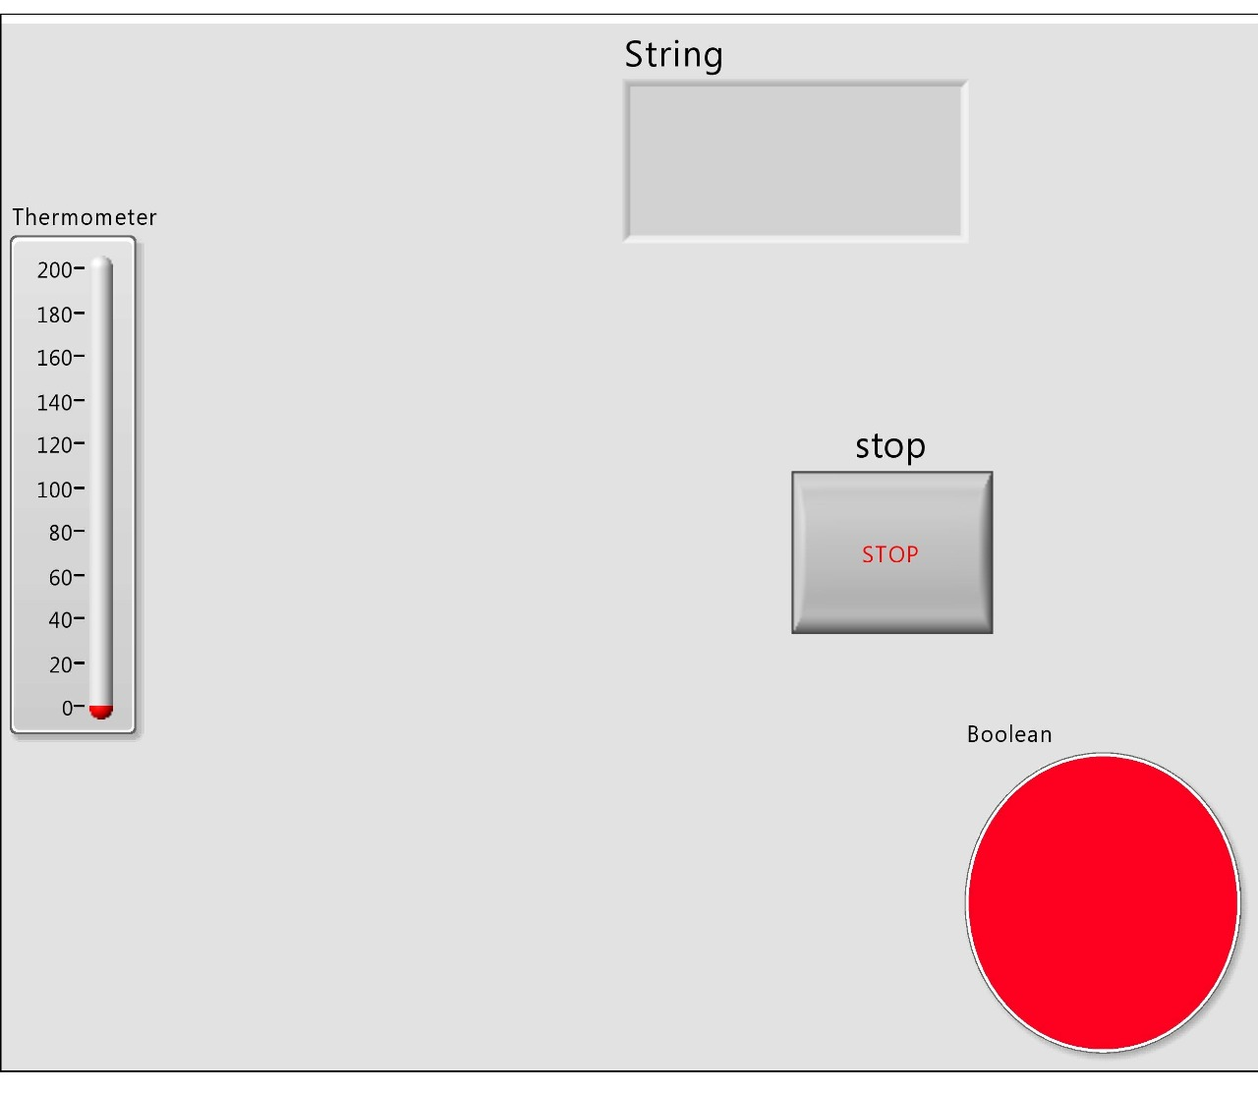18) Temperature limit message

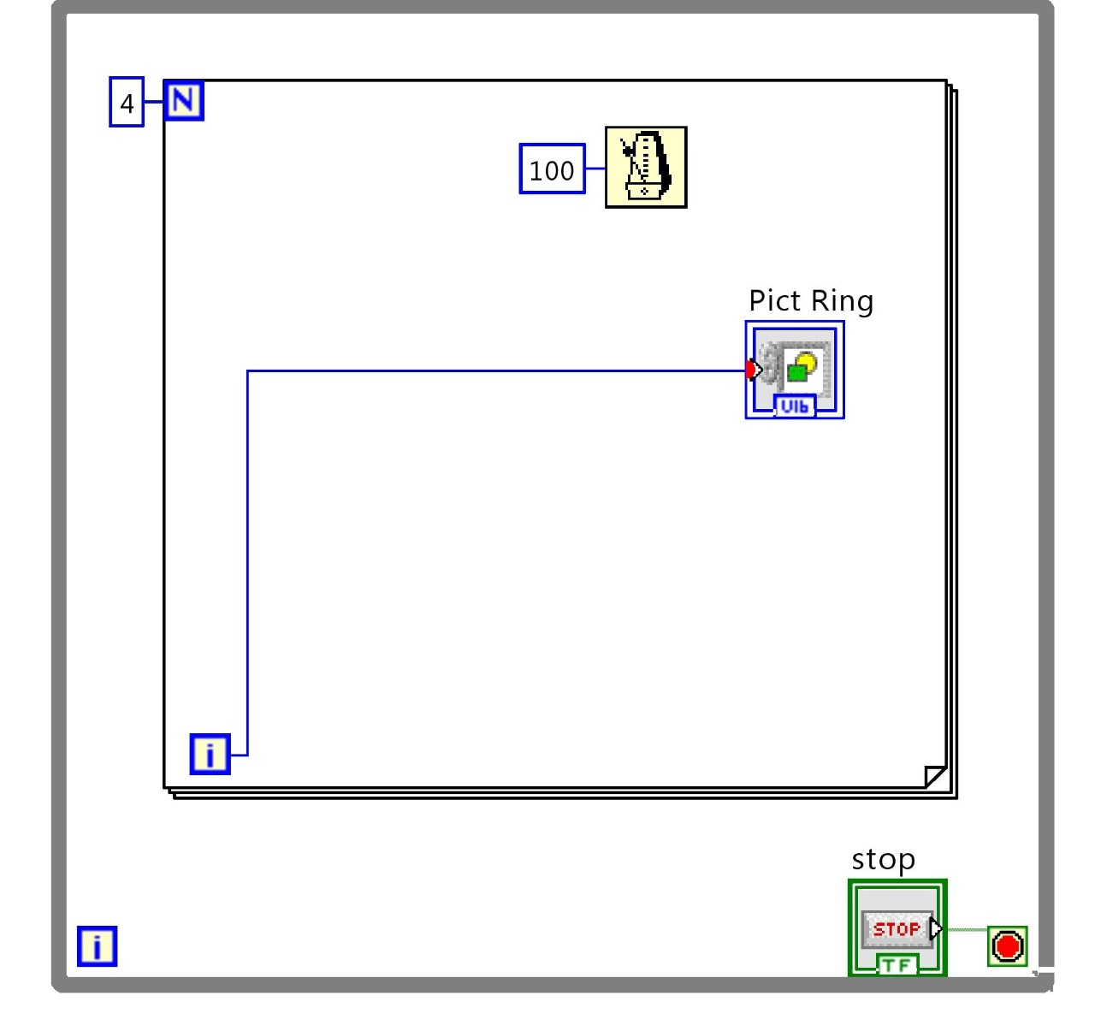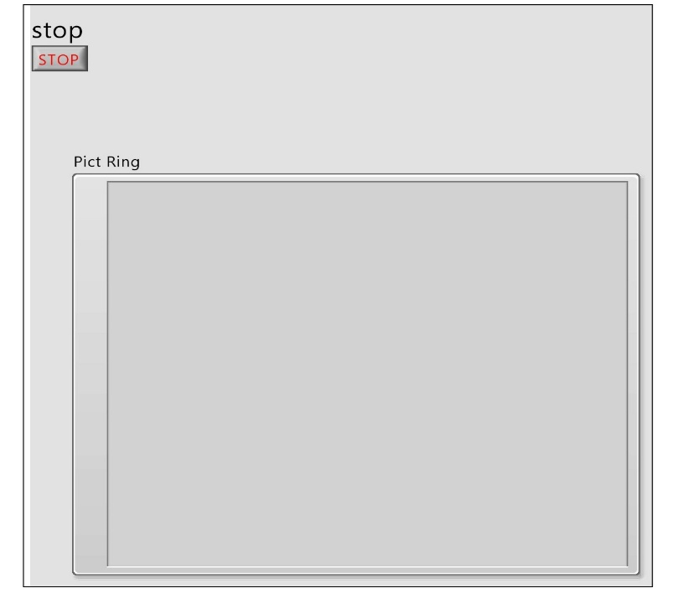19)Using pict ring component for animation

20) accelerometer

21)1 Sensor 5 inputs

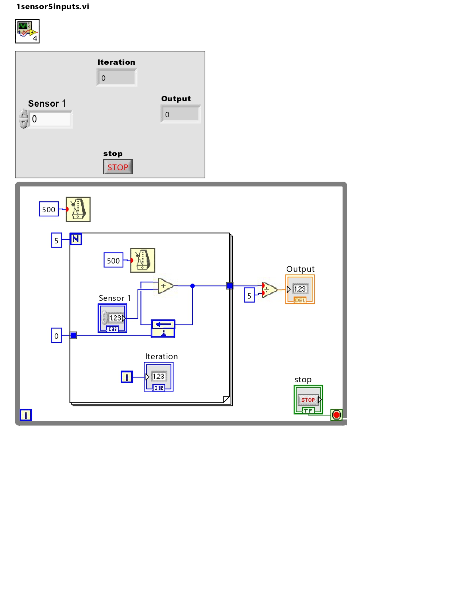

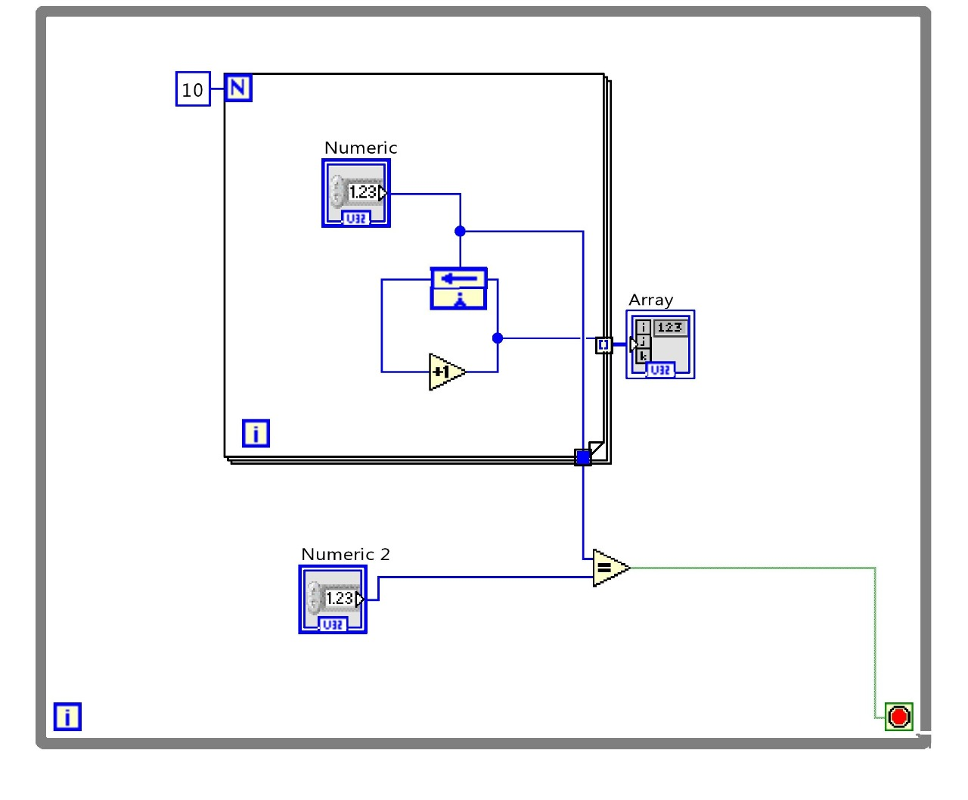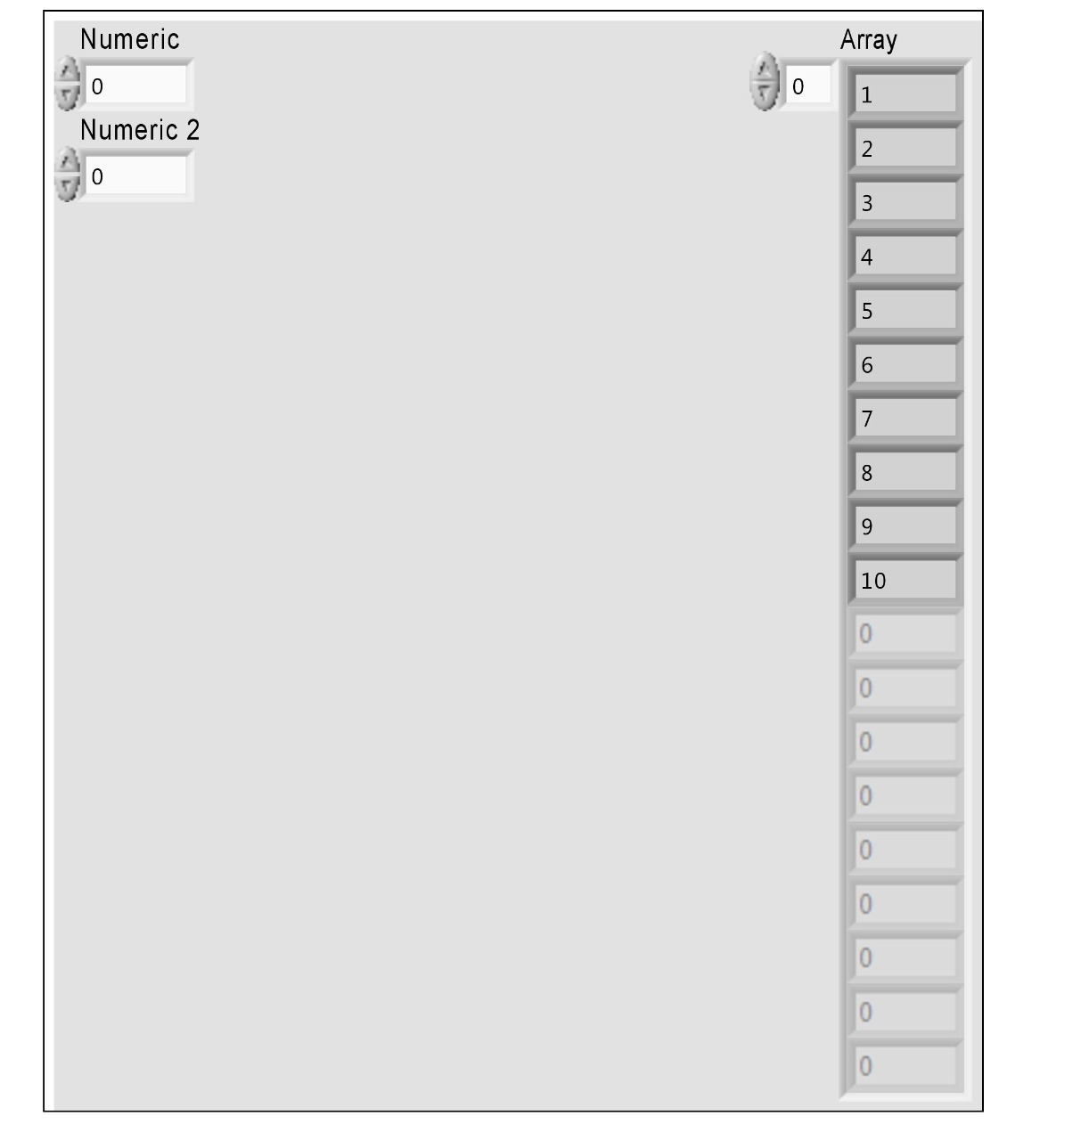22) Array generate and compare

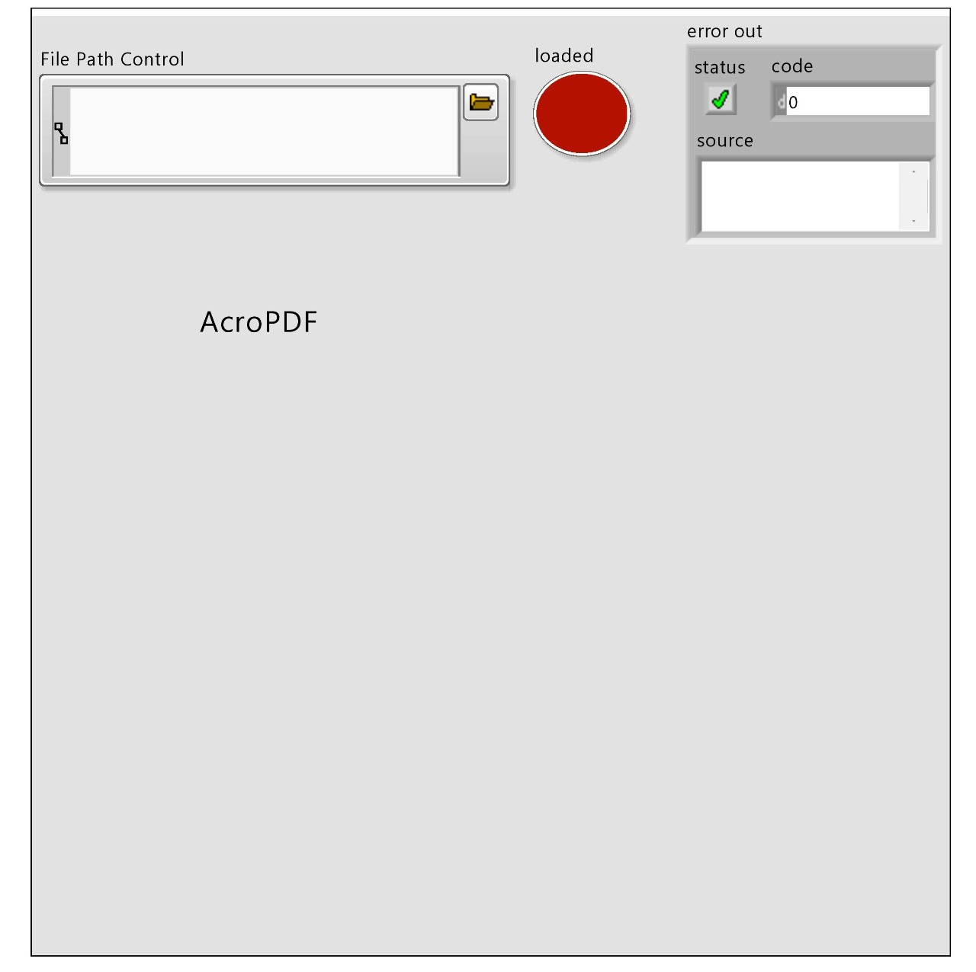23)PDF reader invoke node

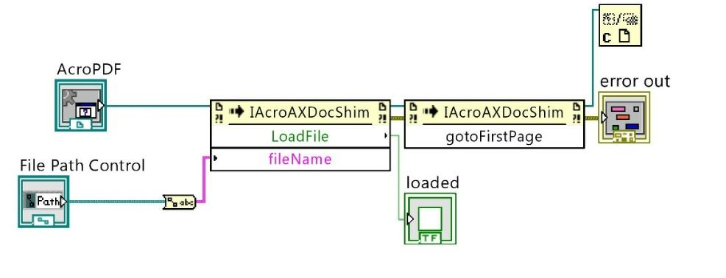

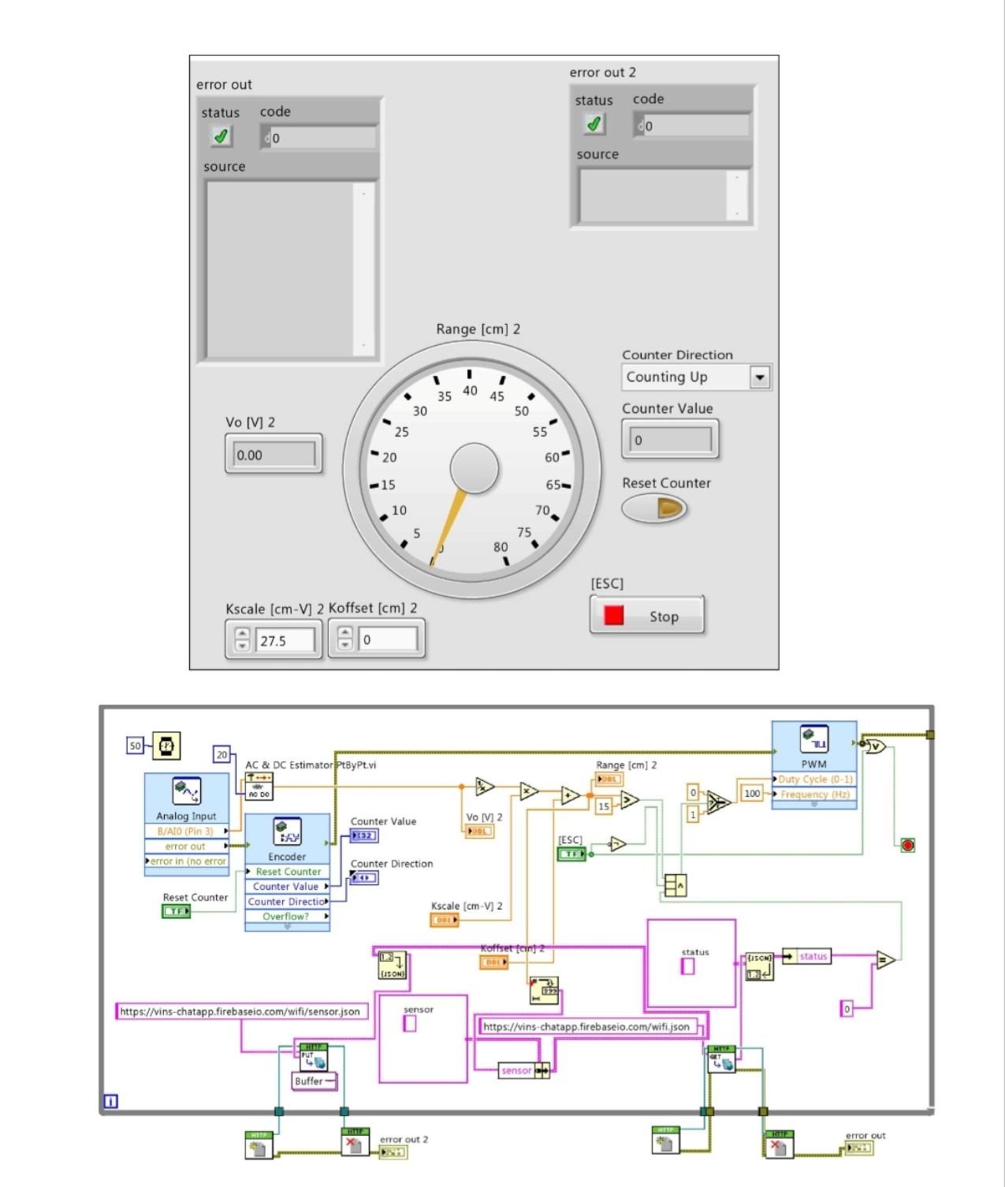24)Motor speed and sensor value control

25)Led control with accelerometer

